**Table of Content**

1. Introduction
2. Objectives
3. Scenario
4. Methodology
5. Model Comparison with different Training Test size
6. Model Improvement
7. Result and Discussion
8. Conclusion
9. Reference
10. **Brief descriptions of individual contributions**
11. **Introduction**

Parkinson’s disease is a brain disorder that causes unintended or uncontrollable movements, such as shaking, stiffness, and difficulty with balance and coordination [1]. Symptoms usually begin gradually and worsen over time. As the disease progresses, people may have difficulty walking and talking [1]. Parkinson's disease occurs when the nerve cells in your brain don't make enough of a body chemical called dopamine, which affects your movement and mood [2]. Common symptoms may include tremors, muscle stiffness, slowing of movement and posture changes, but confirming if you have Parkinson's can take time [2]. There are a wide variety of other symptoms that may or may not experienced and could be caused by different conditions [2]. Parkinson’s disease usually occurs around age 65 years, but some people can be diagnosed when they are younger than 45 years [2]. Medicine, surgery and lifestyle changes can help treat and improve quality of life with Parkinson’s disease [2]. This project is about to identify the Parkinson’s diseases patient using a range of variables data. A multiple regression model is built to predict the motor UPDRS and total UPDRS which are the two main differentiating factors to determine whether a person is a PPD patient or not. Also, the values of these two variables indicate the severity of affect of Parkinson’s disease. The motor UPDRS score range from 0 to 180, where 0 indicates Parkinson’s Disease symptoms free and 180 indicates severe motor disorder. In the case of total UPDRS, it ranges from 0 to 176 and 0 stands for healthy condition and 176 denotes total disability of untreated patients. Along with the multiple regression model python data visualization will also be used for better understanding.

To generate the multiple regression models all the variables are divided into two categories:

1. **Explanatory Variable:** It is also known as independent or predictor variable and indicates the variations in the response variable [3]. In experiment this variable is manipulated by the researcher [3]. In simple linear regression there is only one explanatory variable but in multiple linear regression there is more than one explanatory variable.
2. **Response Variable:** Also known as the *dependent*or *outcome variable,*its value is predicted or its variation is explained by the explanatory variable; in an experimental study, this is the outcome that is measured following manipulation of the explanatory variable [3]. Only one variable can be predicted at a time both for simple linear regression and multiple linear regression.

In this project motor UPDRS and total UPDRS are the response variables and remaining are the explanatory variables, except the subject variable which is actually a sequential number.

1. **Objective**

The prediction of motor and total UPDRS assigned by a physician to people with Parkinson’s disease.

1. **Scenario**

As we have to predict two variables from a single data set, so in that case there should be two types of scenarios.

**Scenario 1**: Predicting motor UPDRS by excluding total UPDRS from explanatory variables and predicting total UPDRS by excluding motor UPDRS from explanatory variables set.

**Scenario 2**: Predicting motor UPDRS by including total UPDRS from explanatory variables and predicting total UPDRS by including motor UPDRS from explanatory variables set.

1. **Methodology**

First, we have done data wrangling onto our dataset to structure our data and replace the missing data with mean value of that particular variable.

Then we build the multiple regression and train our model using 4 different scenarios

1. Train and test the model by splitting the data set in 50-50 portion.
2. Train and test the model by splitting the data set in 60-40 portion.
3. Train and test the model by splitting the data set in 70-30 portion.
4. Train and test the model by splitting the data set in 80-20 portion.

MAE, MSE, RMSE, RMSE (Normalize), R-squared and adjusted R-squared are calculated and compared with the base model to find our model fitness.

OLS multiple regression is used to evaluate the model summary and identify where to improve.

In the end to improve the generated model four different techniques is used and results are compared as well.

1. Make the explanatory variables linear with response variable by log transformation.
2. Reducing collinearity by dropping the variables which P-value are not significant and have strong collinearity among themselves.
3. Make the variables standard by Z-Standardization technique.
4. Convert the variables distribution into normal distribution by Gaussian transformation.

To identify the linear relationship of explanatory variables with the response variables python visualization technique has been used.

1. **Model Comparison with different Training Test Size**

|  |  |  |  |  |  |
| --- | --- | --- | --- | --- | --- |
| **Scenario 1** | | | | | |
| **Motor UPDRS Prediction** | | | **Total UPDRS Prediction** | | |
| **Traning/Test - 50/50** | | | **Traning/Test - 50/50** | | |
| **Critical Factor** | **MLR** | **Baseline** | **Critical Factor** | **MLR** | **Baseline** |
| MAE | 6.3021 | 6.9183 | MAE | 7.9648 | 8.5529 |
| MSE | 55.3304 | 65.1203 | MSE | 92.8183 | 112.2265 |
| RMSE | 7.4384 | 8.0697 | RMSE | 9.6342 | 10.5937 |
| RMSE (Normalized) | 0.2157 | 0.234 | RMSE (Normalized) | 0.2007 | 0.2207 |
| R-Squared | 0.1503 | -2.56^-6 | R-Squared | 0.1729 | -1.86^-6 |
| **Traning/Test - 60/40** | | | **Traning/Test - 60/40** | | |
| **Critical Factor** | **MLR** | **Baseline** | **Critical Factor** | **MLR** | **Baseline** |
| MAE | 6.2996 | 6.9018 | MAE | 7.9704 | 8.5392 |
| MSE | 55.6773 | 65.0377 | MSE | 93.6126 | 111.6499 |
| RMSE | 7.4617 | 8.0645 | RMSE | 9.6753 | 10.5664 |
| RMSE (Normalized) | 0.2164 | 0.2339 | RMSE (Normalized) | 0.2016 | 0.2201 |
| R-Squared | 0.1438 | -5.28^-5 | R-Squared | 0.1615 | -6.29^-8 |
| **Traning/Test - 70/30** | | | **Traning/Test - 70/30** | | |
| **Critical Factor** | **MLR** | **Baseline** | **Critical Factor** | **MLR** | **Baseline** |
| MAE | 6.3124 | 6.8904 | MAE | 7.941 | 8.5193 |
| MSE | 55.7016 | 65.026 | MSE | 92.304 | 110.3248 |
| RMSE | 7.4633 | 8.0638 | RMSE | 9.6075 | 10.5035 |
| RMSE (Normalized) | 0.2164 | 0.2339 | RMSE (Normalized) | 0.2001 | 0.2188 |
| R-Squared | 0.1428 | -0.0006 | R-Squared | 0.1601 | -0.0005 |
| **Traning/Test - 80/20** | | | **Traning/Test - 80/20** | | |
| **Critical Factor** | **MLR** | **Baseline** | **Critical Factor** | **MLR** | **Baseline** |
| MAE | 6.3553 | 6.1949 | MAE | 8.0006 | 8.5016 |
| MSE | 56.8998 | 65.3502 | MSE | 94.9962 | 111.4641 |
| RMSE | 7.5432 | 8.0839 | RMSE | 9.7466 | 10.5576 |
| RMSE (Normalized) | 0.2188 | 0.2344 | RMSE (Normalized) | 0.203 | 0.2199 |
| R-Squared | 0.129 | -0.0002 | R-Squared | 0.1477 | -5.78^-9 |

**Table - 1**

|  |  |  |  |  |  |
| --- | --- | --- | --- | --- | --- |
| **Scenario 2** | | | | | |
| **Motor UPDRS Prediction** | | | **Total UPDRS Prediction** | | |
| **Traning/Test - 50/50** | | | **Traning/Test - 50/50** | | |
| **Critical Factor** | **MLR** | **Baseline** | **Critical Factor** | **MLR** | **Baseline** |
| MAE | 1.944 | 6.9183 | MAE | 2.456 | 8.5529 |
| MSE | 6.4049 | 65.1203 | MSE | 10.7557 | 112.2265 |
| RMSE | 2.5308 | 8.0697 | RMSE | 3.2795 | 10.5937 |
| RMSE (Normalized) | 0.0734 | 0.234 | RMSE (Normalized) | 0.0683 | 0.2207 |
| R-Squared | 0.9016 | -2.56^-6 | R-Squared | 0.9041 | -1.86^-6 |
| **Traning/Test - 60/40** | | | **Traning/Test - 60/40** | | |
| **Critical Factor** | **MLR** | **Baseline** | **Critical Factor** | **MLR** | **Baseline** |
| MAE | 1.9216 | 6.9018 | MAE | 2.424 | 8.5392 |
| MSE | 6.2408 | 65.0377 | MSE | 10.4932 | 111.6499 |
| RMSE | 2.4981 | 8.0645 | RMSE | 3.2393 | 10.5664 |
| RMSE (Normalized) | 0.0724 | 0.2339 | RMSE (Normalized) | 0.0674 | 0.2201 |
| R-Squared | 0.904 | -5.28^5 | R-Squared | 0.906 | -6.29^-8 |
| **Traning/Test - 70/30** | | | **Traning/Test - 70/30** | | |
| **Critical Factor** | **MLR** | **Baseline** | **Critical Factor** | **MLR** | **Baseline** |
| MAE | 1.9209 | 6.8904 | MAE | 2.4162 | 8.5193 |
| MSE | 6.2237 | 65.026 | MSE | 10.3121 | 110.3248 |
| RMSE | 2.4947 | 8.0838 | RMSE | 3.2112 | 10.5035 |
| RMSE (Normalized) | 0.0723 | 0.2339 | RMSE (Normalized) | 0.0669 | 0.2188 |
| R-Squared | 0.9042 | -0.0006 | R-Squared | 0.9061 | -0.0005 |
| **Traning/Test - 80/20** | | | **Traning/Test - 80/20** | | |
| **Critical Factor** | **MLR** | **Baseline** | **Critical Factor** | **MLR** | **Baseline** |
| MAE | 1.9402 | 6.9149 | MAE | 2.4533 | 8.5016 |
| MSE | 6.4941 | 65.3502 | MSE | 10.8462 | 111.4641 |
| RMSE | 2.5483 | 8.0839 | RMSE | 3.2933 | 10.5576 |
| RMSE (Normalized) | 0.0739 | 0.2344 | RMSE (Normalized) | 0.0686 | 0.2199 |
| R-Squared | 0.9006 | -0.0002 | R-Squared | 0.9026 | -5.78^-9 |

**Table - 2**

From table 1 and table 2 it can be said that by increasing the portion of training data and decreasing the portion of test data have a very small impact on the model performance. Also MLR models have better fit than the normal baseline model according to MAE, MSE, RMSE, RMSE (Normalized), R-squared value, as these values are smaller than the baseline model value and more close to 1 than the baseline model’s R-squared.

1. **Model Improvement**
2. **Scenario 1**

**Primary Model (Motor UPDRS Prediction)**

Result for primary MLR model to predict motor UPDRS is given below:

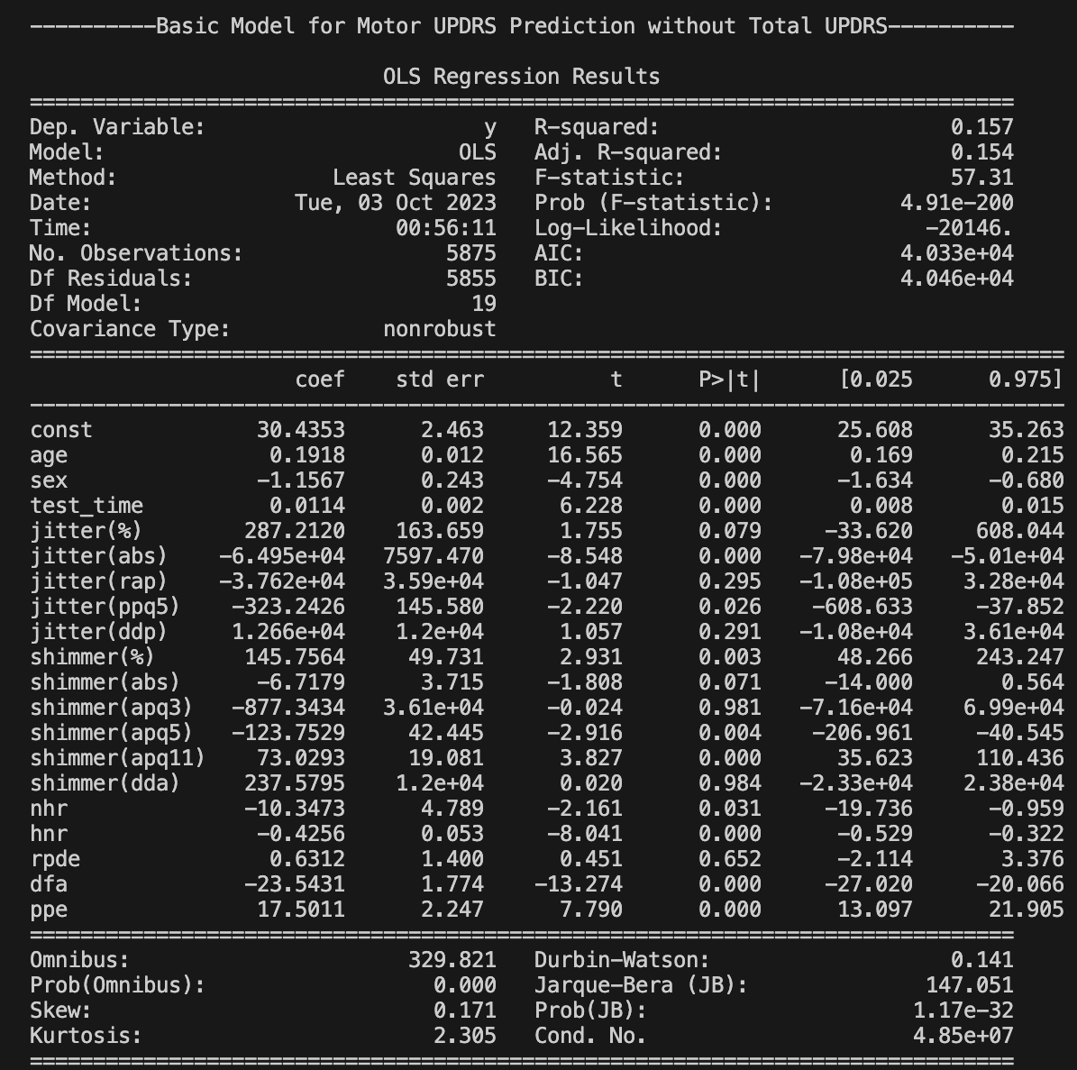

Figure 1

From figure 1 it is visible that R-squared value is 0.157 and Adjusted R-Squared value is 0.154. It seems that model for predicting motor UPDRS with **Scenario 1** is not so good, however 4 types of improvement techniques will be applied to improve the model performance.

To visualize and identify the relation of different variables with motor UPDRS scatter plots have been generated.

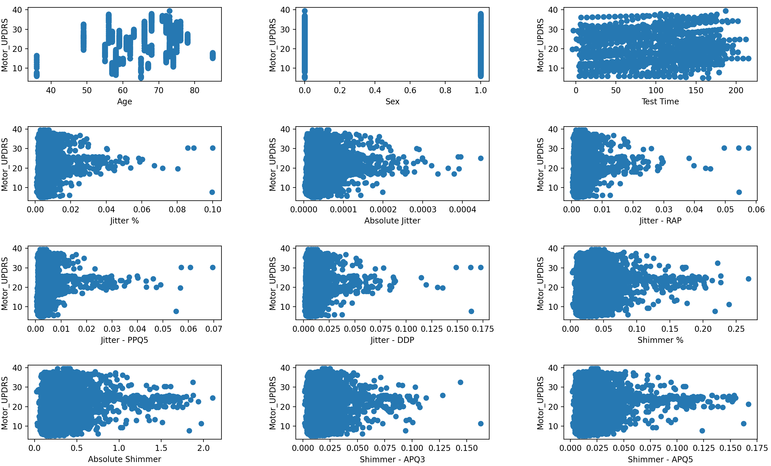

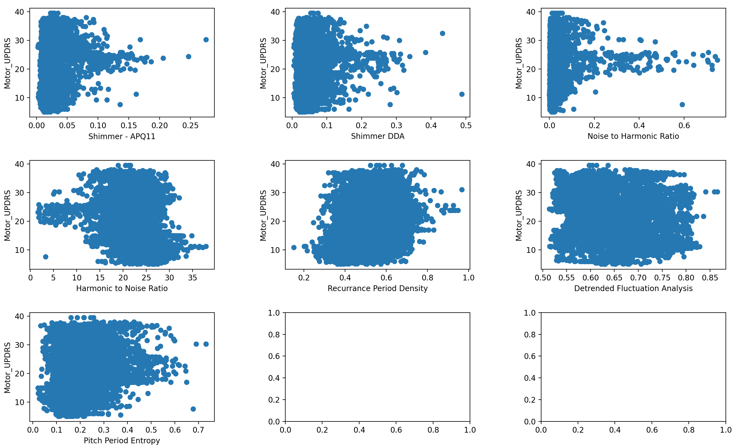

Figure 2

**Linear/Log Transformation (Motor UPDRS Prediction)**

Figure 2 shows that sex, test time, recurrence period density, detrended fluctuation analysis and pitch period entropy have somehow linear relation with motor UPDRS. That’s why log transformation is applied except these columns.

The result of the MLR model after this transformation is as follow.

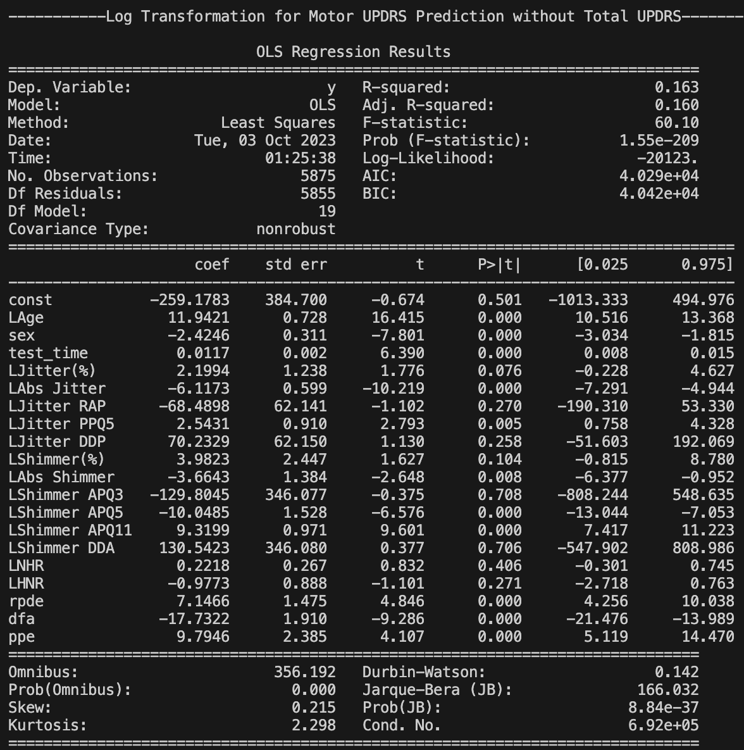

Figure 3

After analysing the figure 1 and figure 3 it can be said due to log transformation or linear transformation the model fitness is improved as R-squared and Adjusted R-squared value are increase from 0.157 and 0.154 to 0.163 and 0.160. So, the model is slightly improved.

Figure 1 shows that jitter(%), jitter(rap), jitter(ddp), shimmer(abs), shimmer(apq3), shimmer(dda), rpe have p-value greater than 0.05 that means these variables have less or no impact in predicting motor UPDRS. Also, these variables have larger correlation with each other, so these variables are dropped to remove the collinearity.

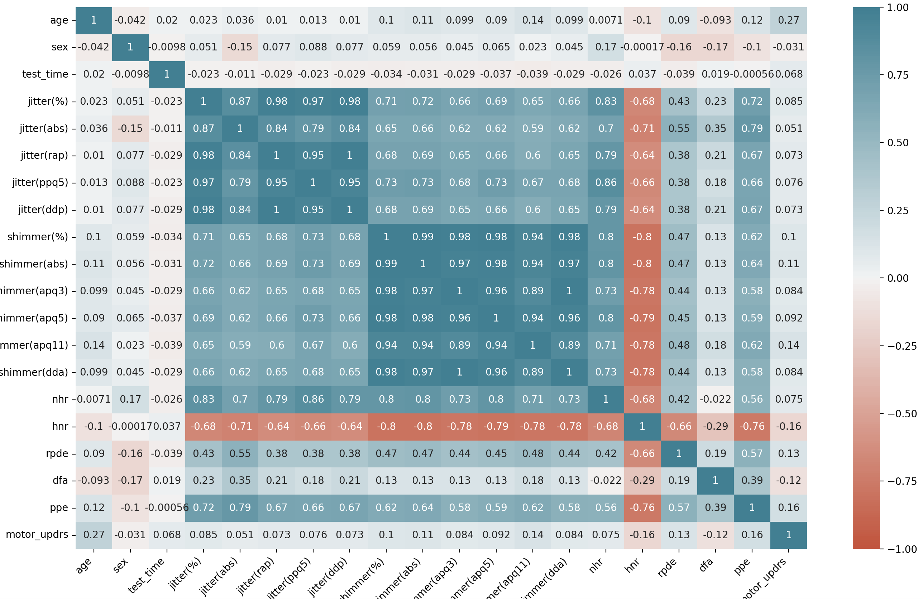

**Removing Collinearity (Motor UPDRS Prediction)**

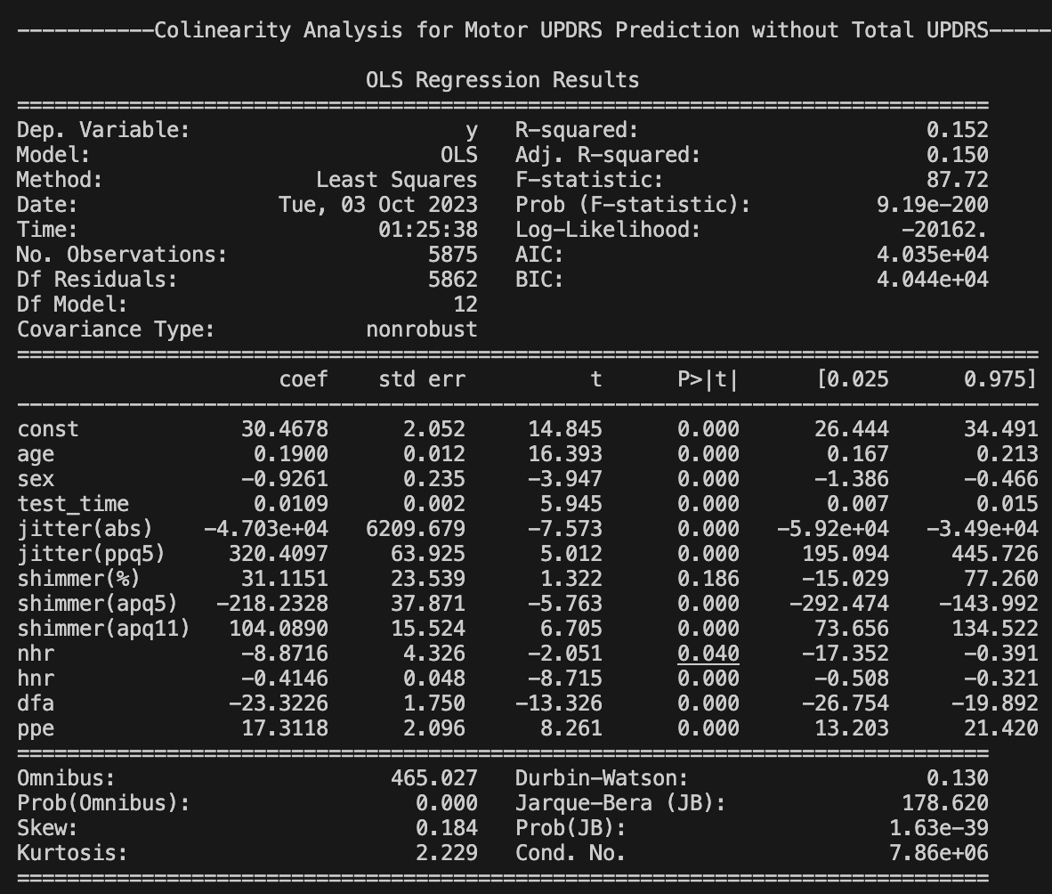

Figure 4

From figure 1 and figure 4 it can be said that after removing collinearity the model becomes worse than before as R-squared and Adjusted R-Squared become reduce.

**Z-Standardization (Motor UPDRS Prediction)**

To make the model to perform better and standardize all the values of explanatory variables we have conducted Z-standardization and observe the improvement.

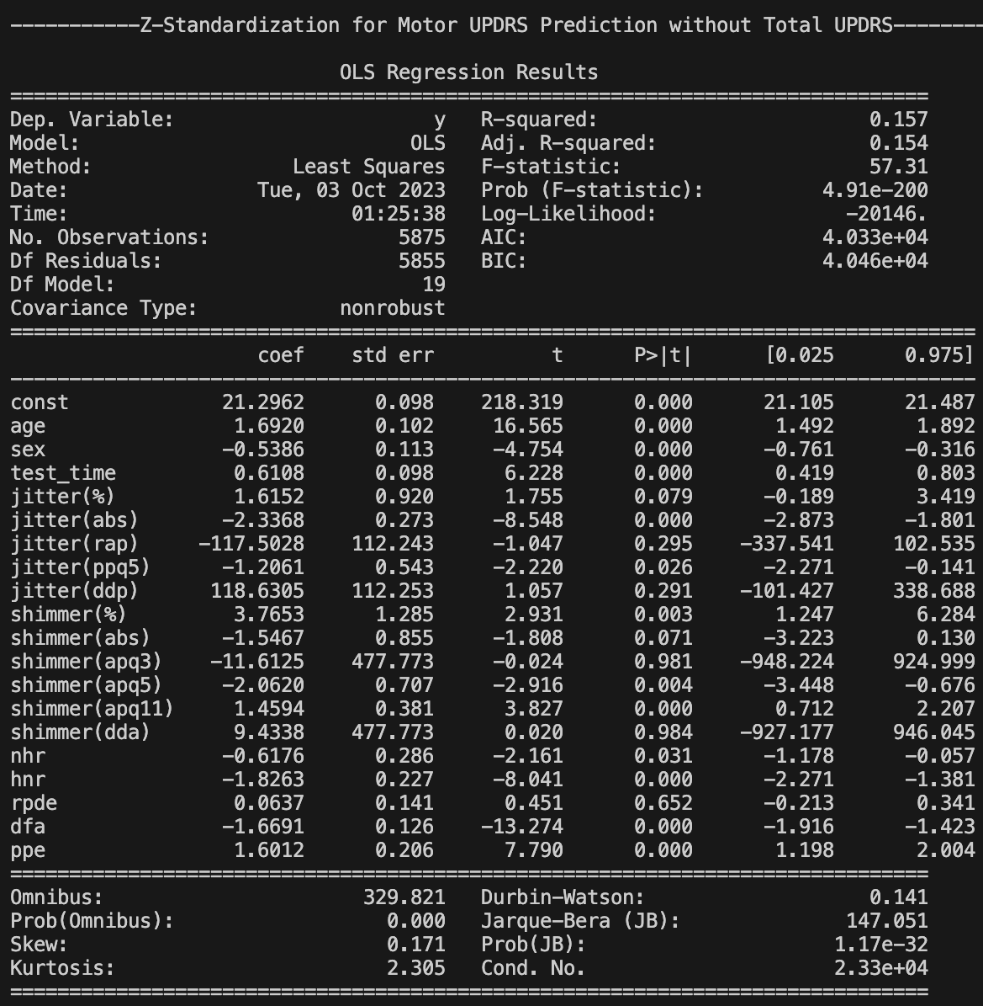

Figure 5

Comparing the R-Squared and Adjusted R-Squared value of the model of figure 5 with the primary model of figure 1, it is clearly observed that there is no improvement after executing this technique.

**Gaussian Transformation** **(Motor UPDRS Prediction)**

To make the explanatory variables normally distributed and improve the model performance Gaussian transformation is applied over the explanatory variables and observed the result.

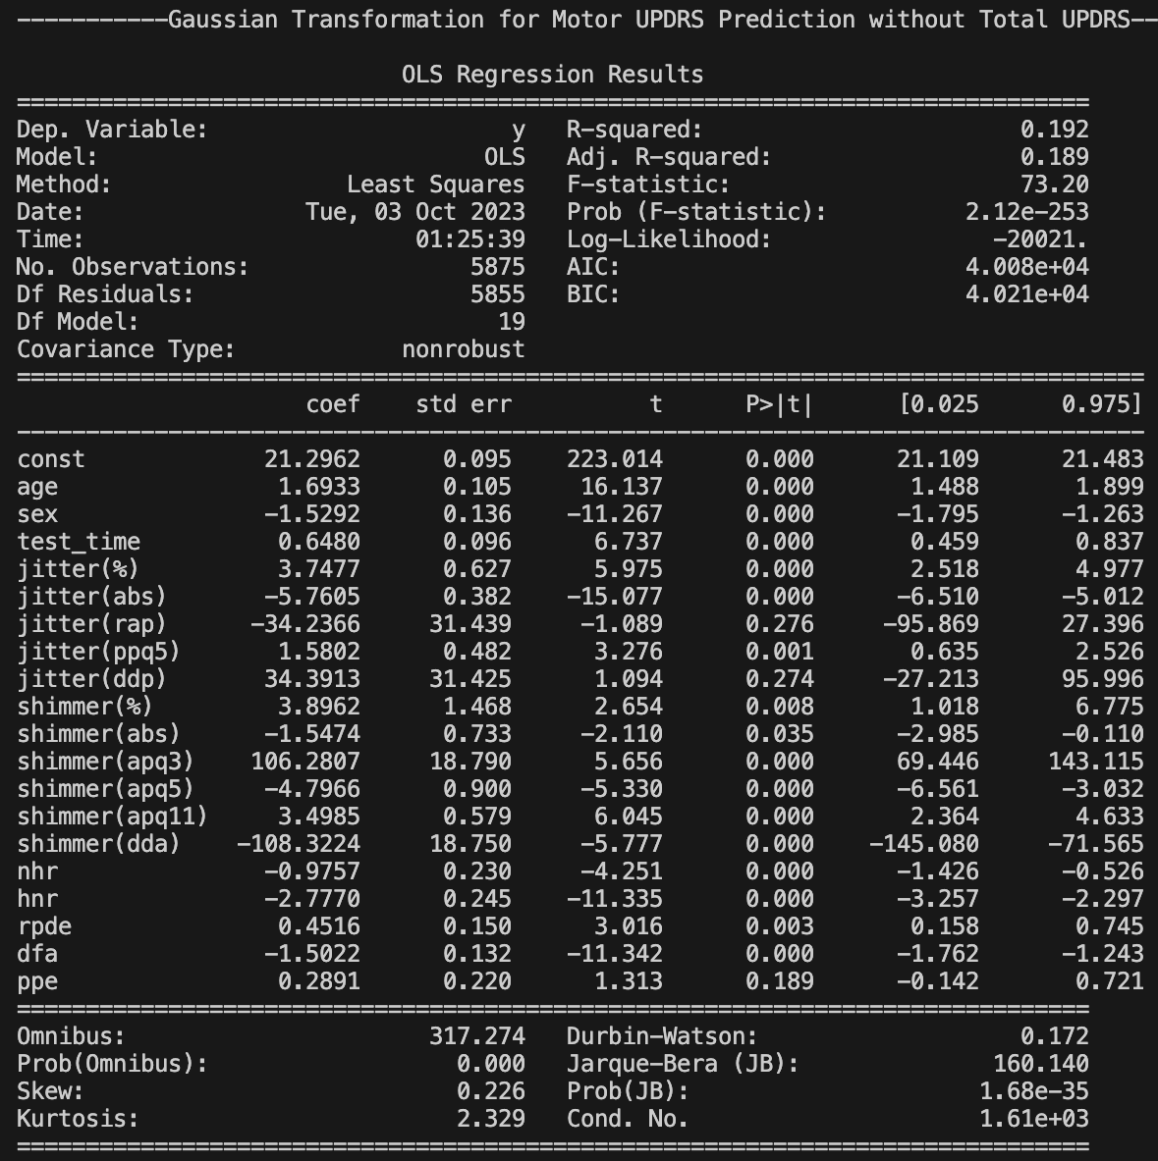

Figure 6

By comparing figure 6 with figure 1 it is clearly visible that model performance is increased as R-Squared value increases from 0.157 to 0.192 and adjusted R-squared value increases from 0.154 to 0.189.

**Primary Model (Total UPDRS Prediction)**

Result for primary MLR model to predict total UPDRS is given below:

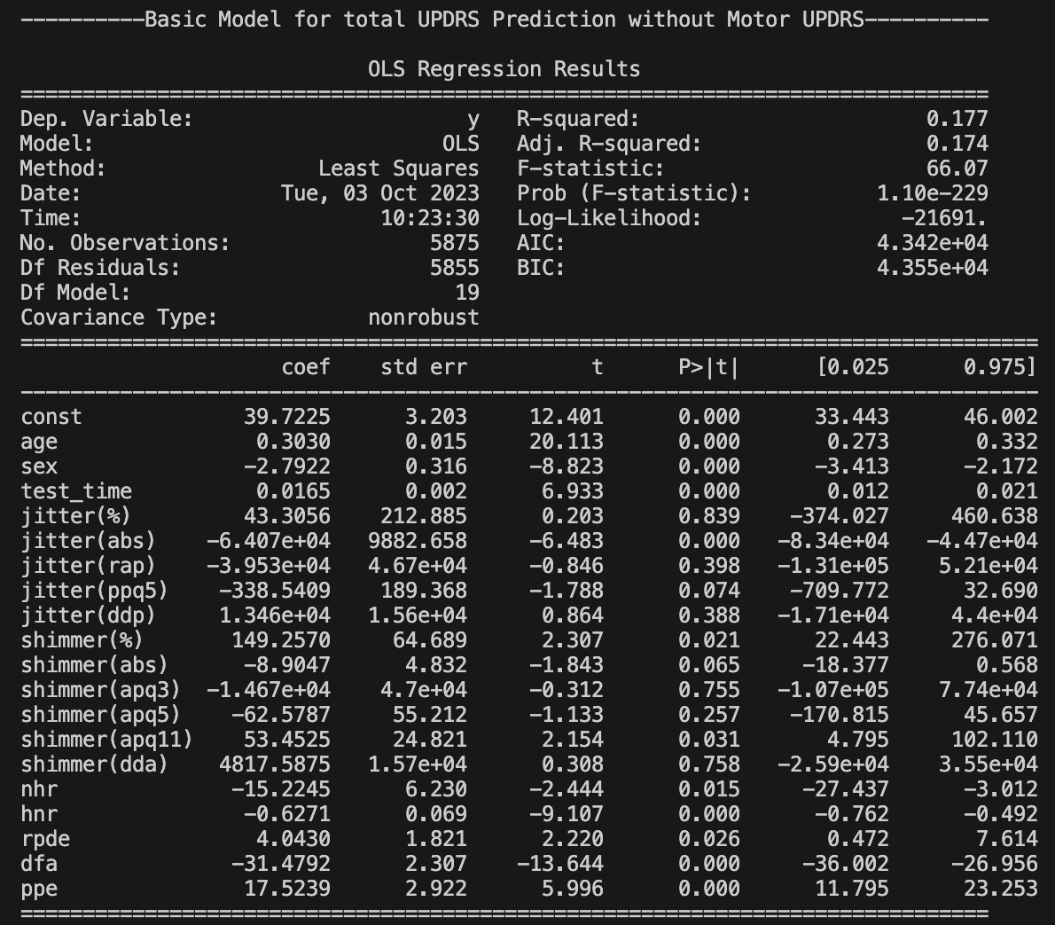

Figure 7

From figure 7 it is visible that R-squared value is 0.177 and Adjusted R-Squared value is 0.174. It seems that model for predicting total UPDRS with **Scenario 1** is not so good, however 4 types of improvement techniques will be applied to improve the model performance.

To visualize and identify the relation of different variables with motor UPDRS scatter plots have been generated.

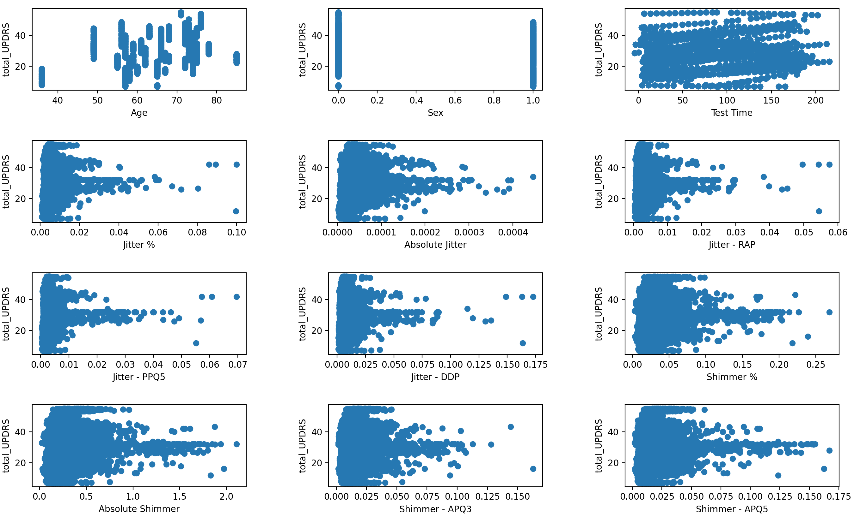

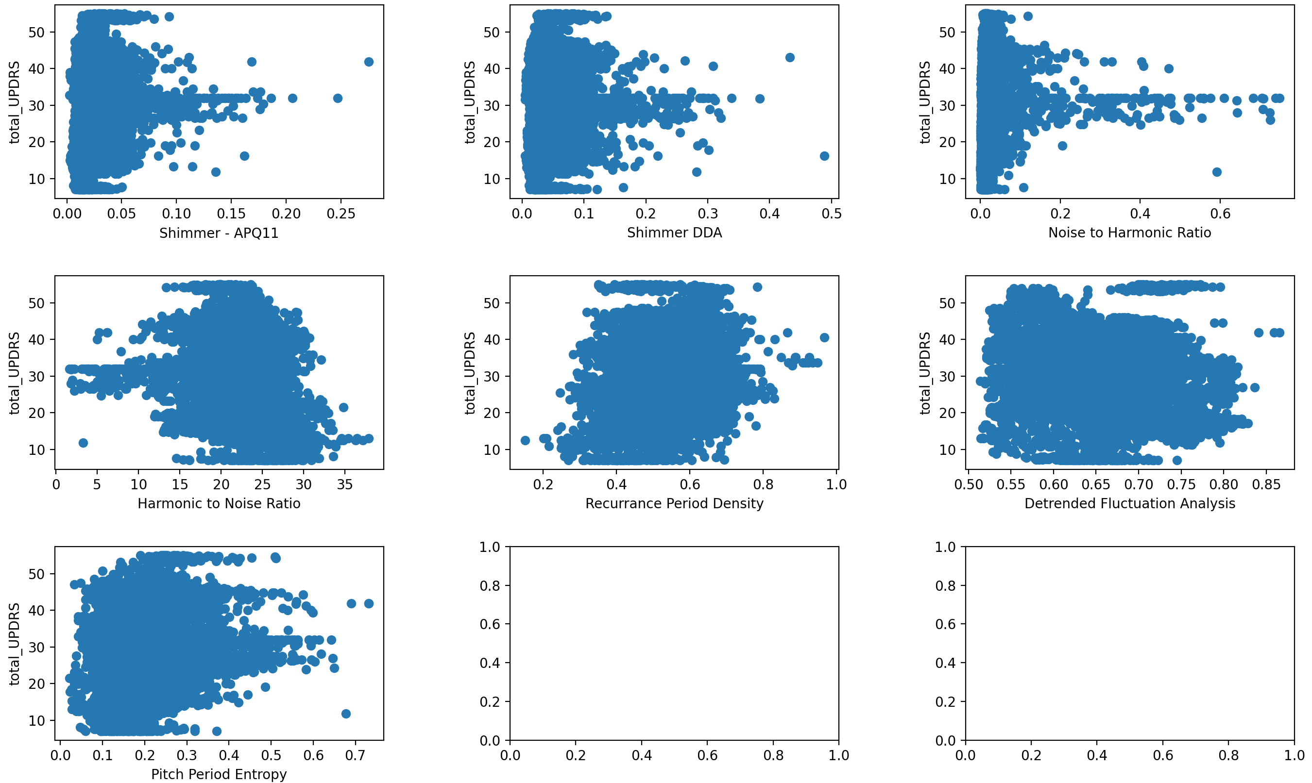

Figure 8

**Linear/Log Transformation (Total UPDRS Prediction)**

Figure 8 shows that sex, test time, recurrence period density, detrended fluctuation analysis, harmonic to noise ratio and pitch period entropy have somehow linear relation with motor UPDRS. That’s why log transformation is applied except these columns. The result of the MLR model after this transformation is as follow.

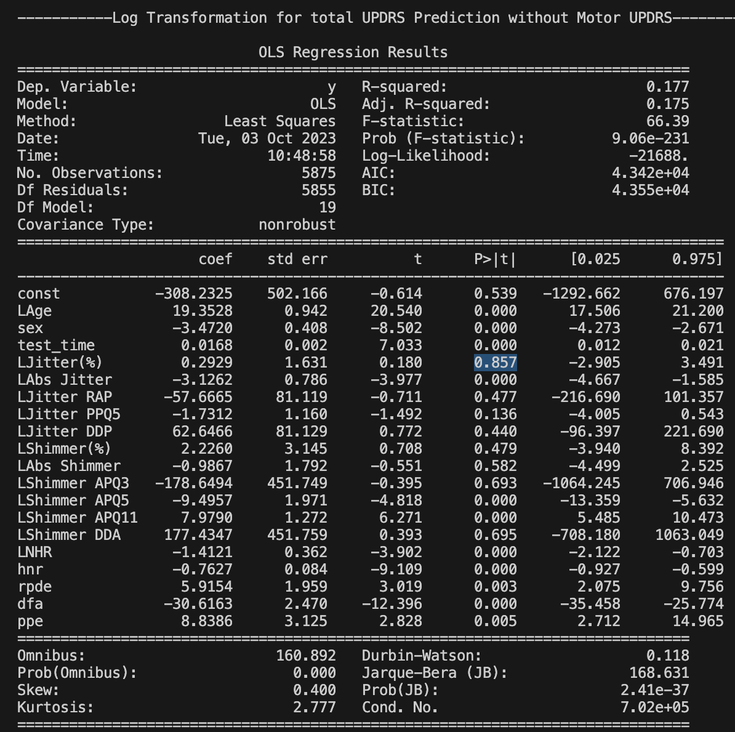

Figure 9

By comparing the R-squared and adjusted R-squared value of figure 7 and figure 9, it is clearly visible that after applying log transformation the model doesn’t improve rather remains the same.

Figure 7 shows that jitter(%), jitter(rap), jitter(ppq5), jitter(ddp), shimmer(abs), shimmer(apq3), shimmer(apq5), shimmer(dda), have p-value greater than 0.05 that means these variables have less or no impact in predicting motor UPDRS. Also, these variables have larger correlation with each other, so these variables are dropped to remove the collinearity.

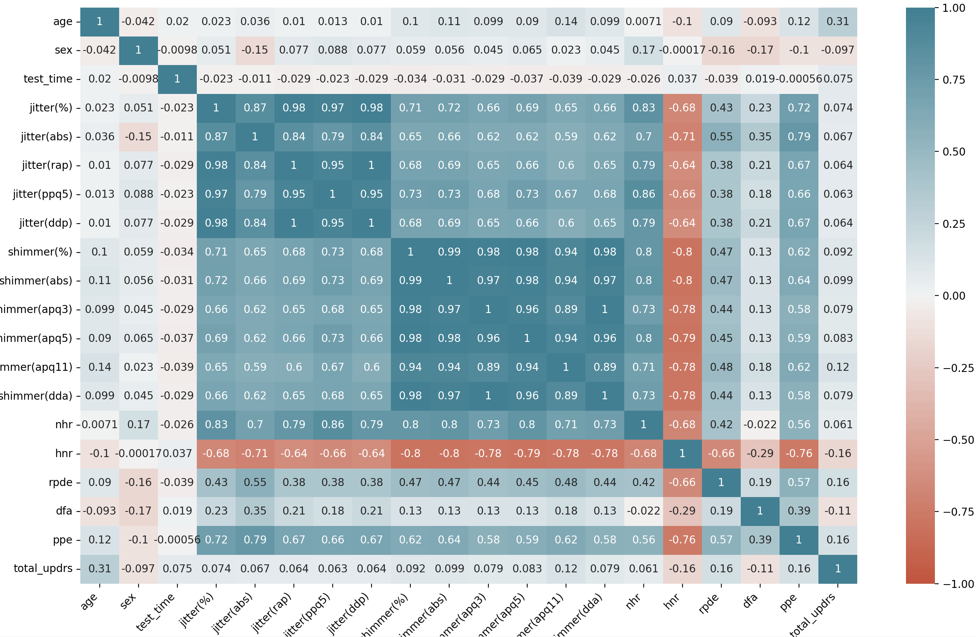

Figure 10

**Removing Collinearity (Total UPDRS Prediction)**

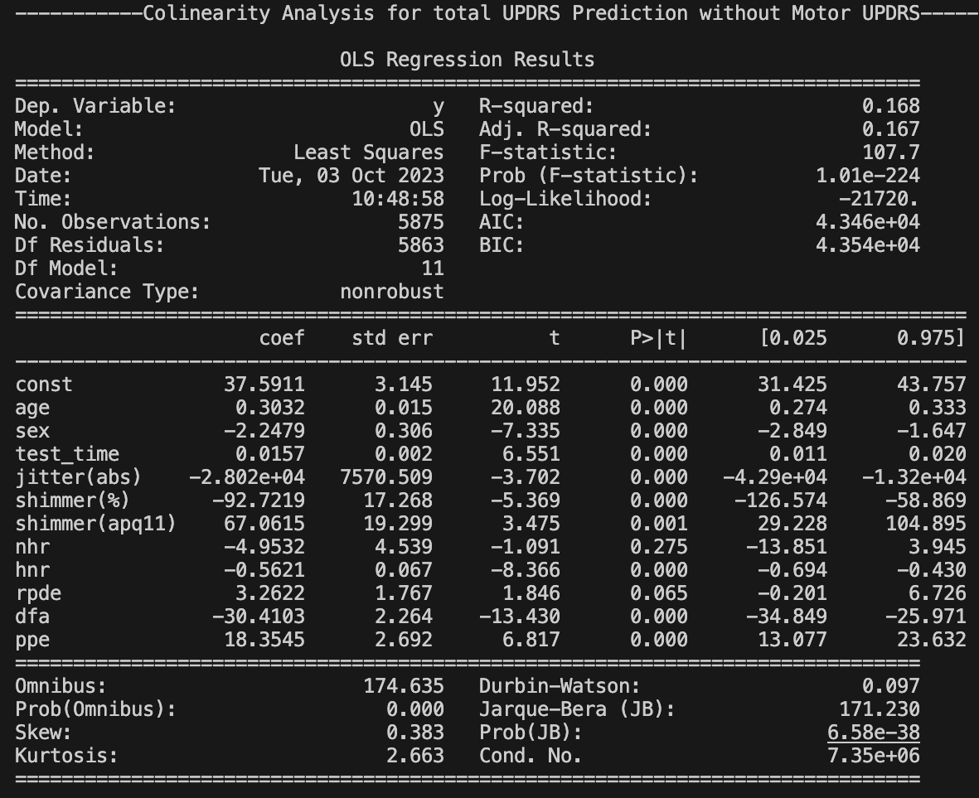

Figure 11

From figure 7 and figure 11 it can be said that after removing collinearity the model becomes worse than before as R-squared and Adjusted R-Squared become reduce.

**Z-Standardization (Total UPDRS Prediction)**

To make the model to perform better and standardize all the values of explanatory variables we have conducted Z-standardization and observe the improvement.

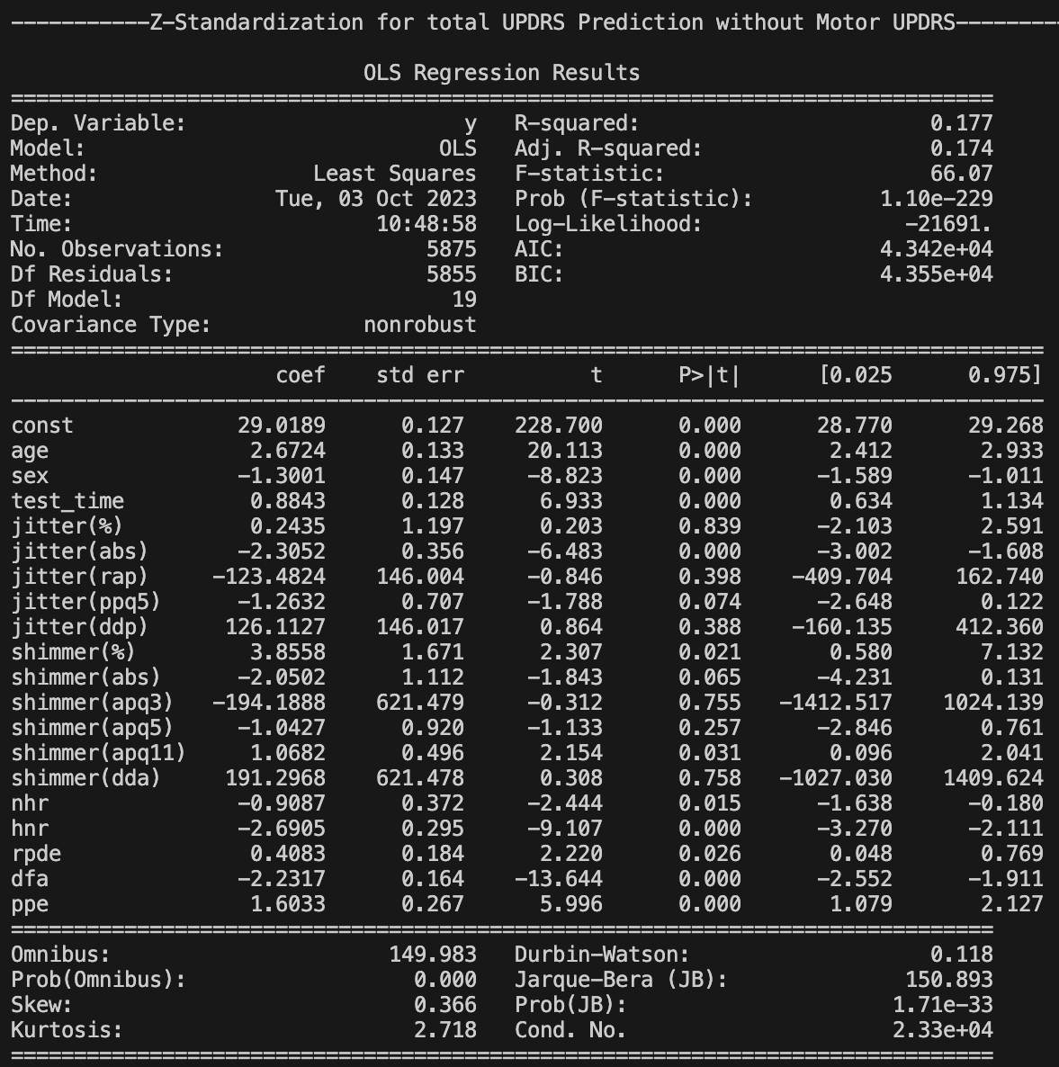

Figure 12

Comparing the R-Squared and Adjusted R-Squared value of the model of figure 12 with the primary model of figure 7, it is clearly observed that there is no improvement after executing this technique.

**Gaussian Transformation** **(Total UPDRS Prediction)**

To make the explanatory variables normally distributed and improve the model performance Gaussian transformation is applied over the explanatory variables and observed the result.

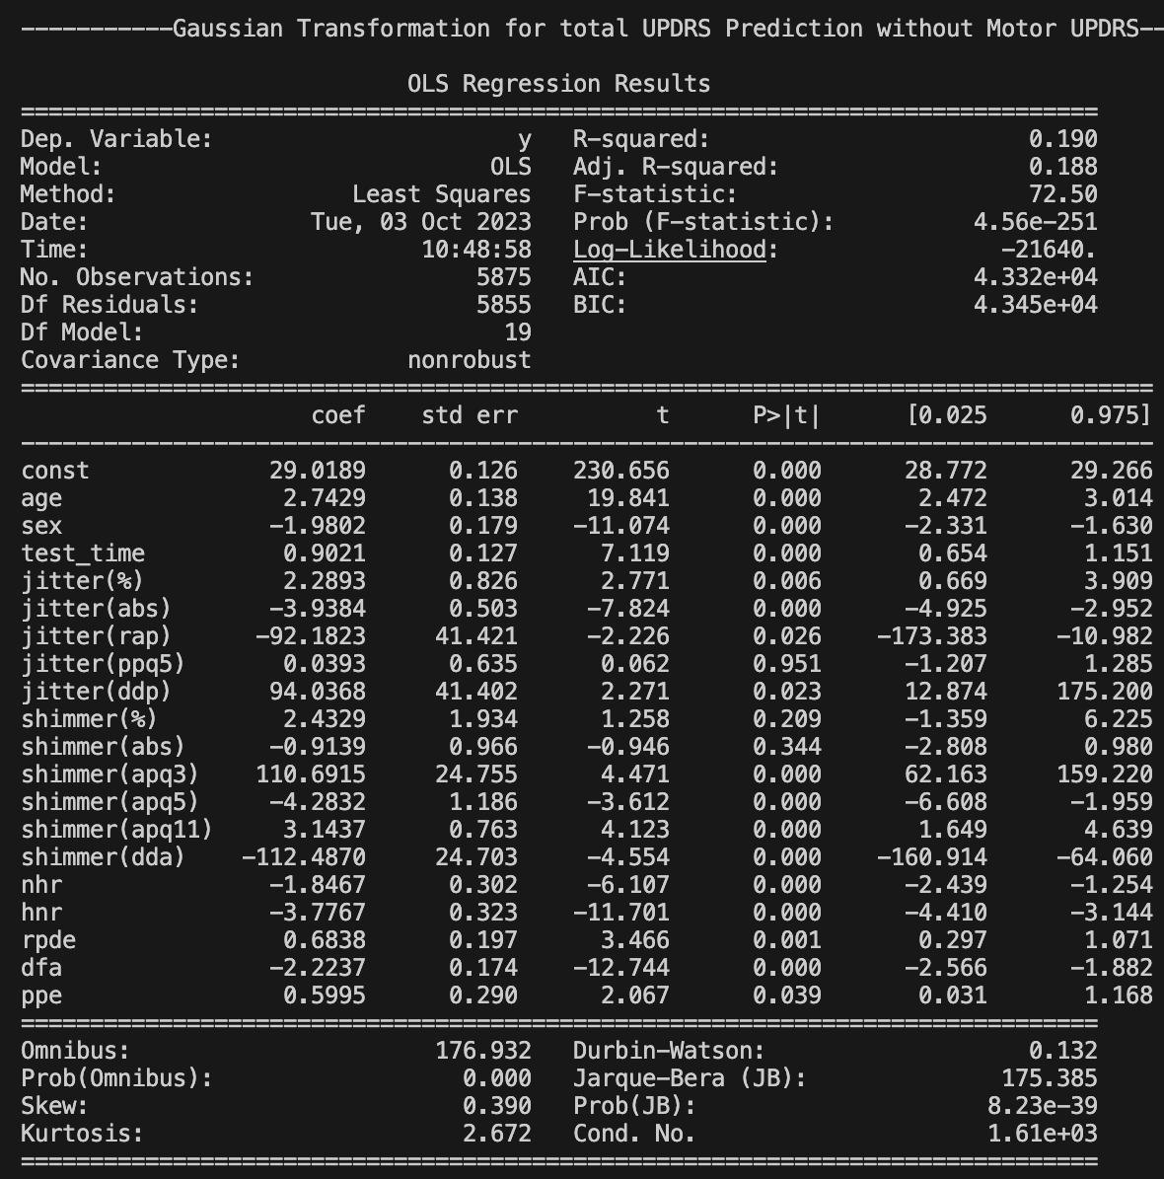

Figure 13

By comparing figure 13 with figure 7 it is clearly visible that model performance is increased as R-Squared value increases from 0.177 to 0.190 and adjusted R-squared value increases from 0.174 to 0.188.

1. **Scenario 2**

**Primary Model (Motor UPDRS Prediction)**

Result for primary MLR model to predict motor UPDRS is given below:

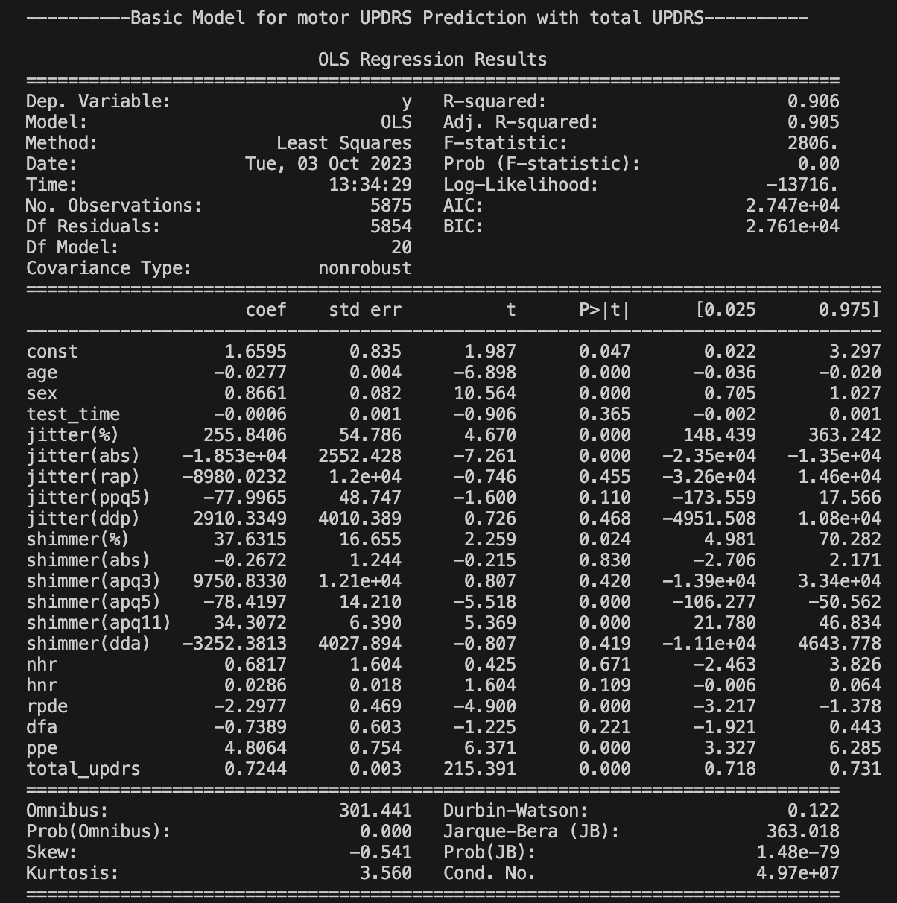

Figure 14

From figure 14 it is visible that R-squared value is 0.906 and Adjusted R-Squared value is 0.905. It seems that model for predicting motor UPDRS with **Scenario 2** is good fit, however 4 types of improvement techniques will be applied to improve the model performance.

To visualize and identify the relation of different variables with motor UPDRS scatter plots have been generated.

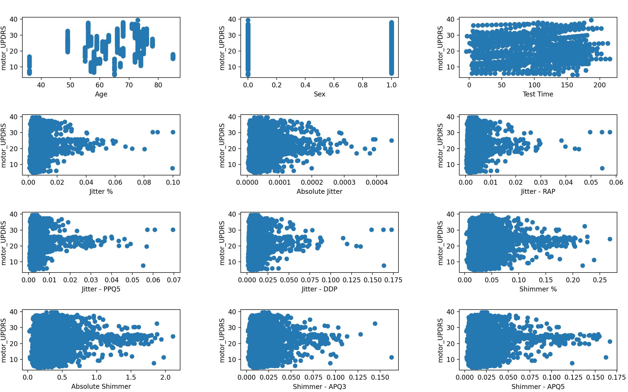

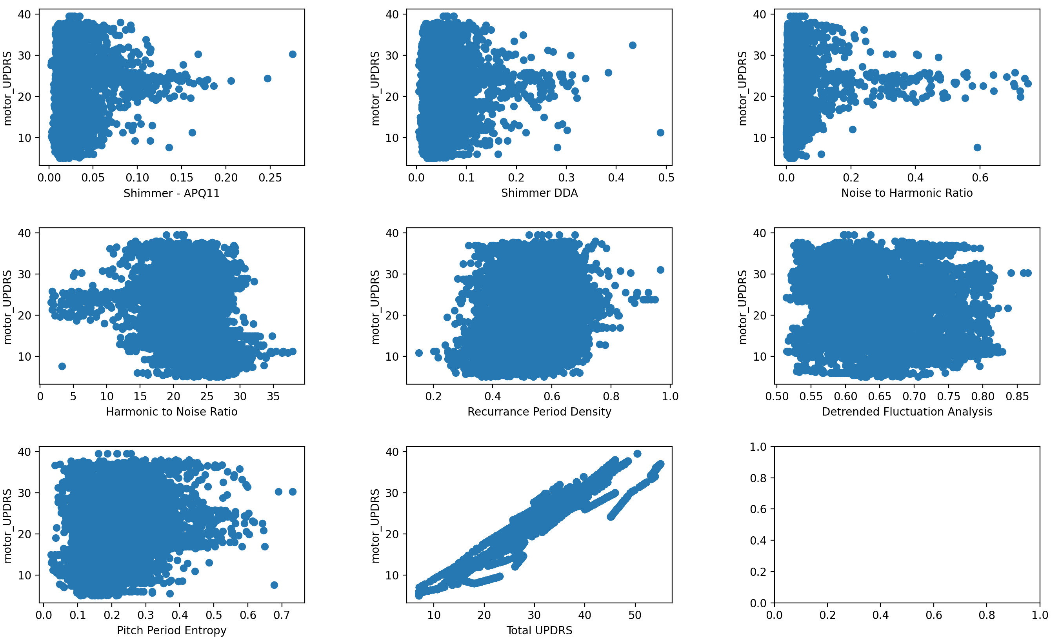

Figure 15

From the figure it can be said that only the total UPDRS has strong and positive correlation with motor UPDRS.

**Linear/Log Transformation (Motor UPDRS Prediction)**

Figure 15 shows that sex, test time, recurrence period density, detrended fluctuation analysis and pitch period entropy have somehow linear relation with motor UPDRS. That’s why log transformation is applied except these columns. The result of the MLR model after this transformation is as follow.

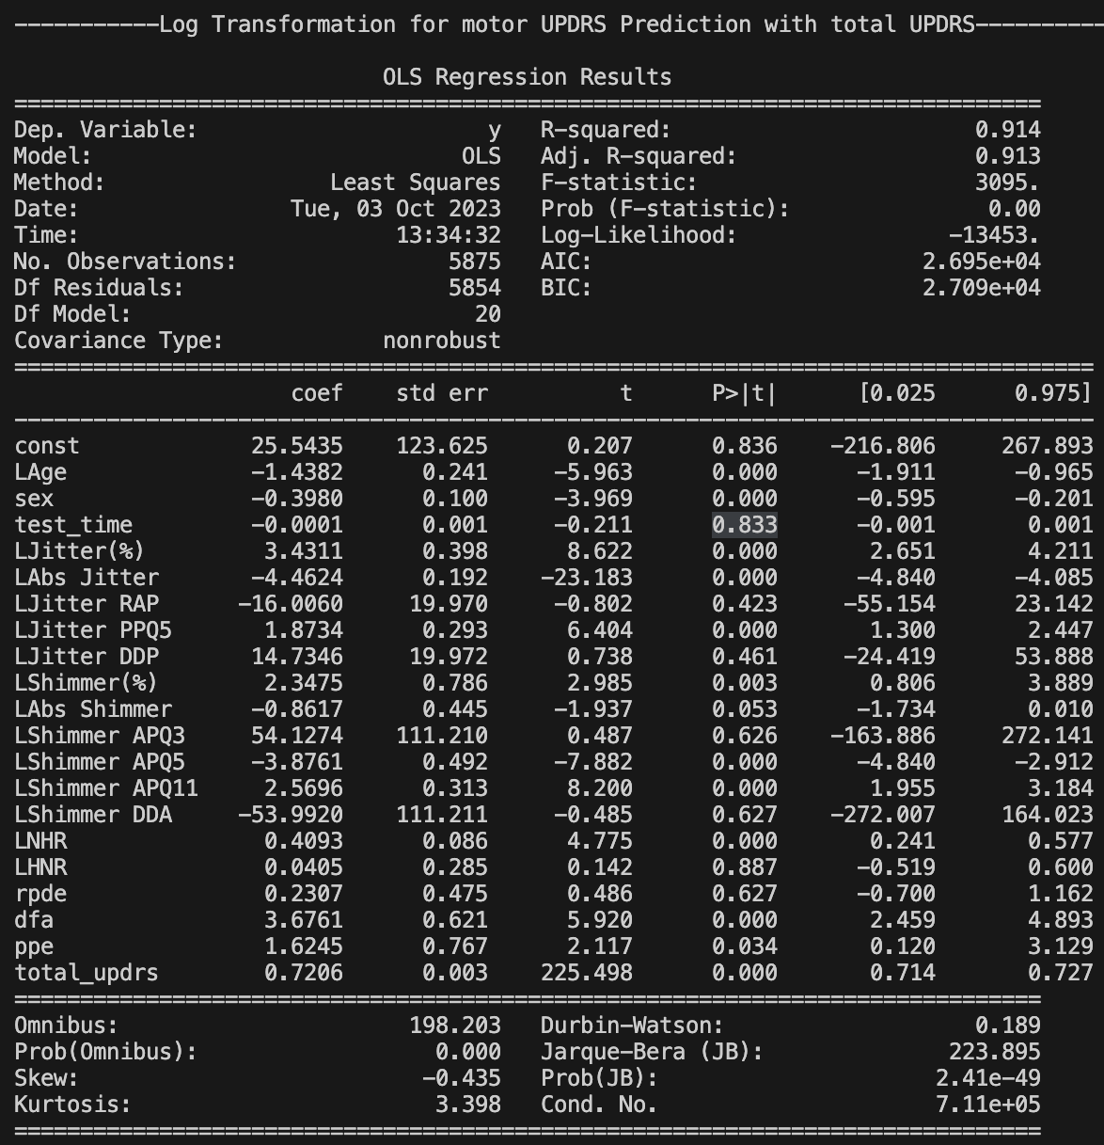

Figure 16

By comparing the R-squared and adjusted R-squared value of figure 16 and figure 15, it is clearly visible that after applying log transformation the model does improve. R-squared value goes up from 0.906 to 0.914 and adjusted R-squared value increases from 0.905 to 0.913.

Figure 14 shows that jitter(rap), jitter(ppq5), jitter(ddp), shimmer(abs), shimmer(apq3), shimmer(dda), nhr, hnr, dfa have p-value greater than 0.05 that means these variables have less or no impact in predicting motor UPDRS. Also, these variables have larger correlation with each other, so these variables are dropped to remove the collinearity.

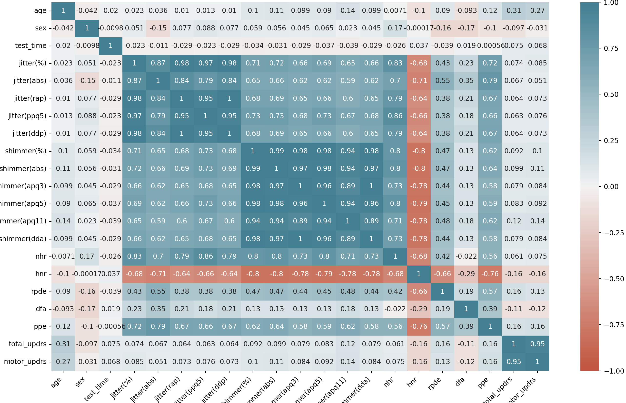

Figure 17

**Removing Collinearity (Motor UPDRS Prediction)**

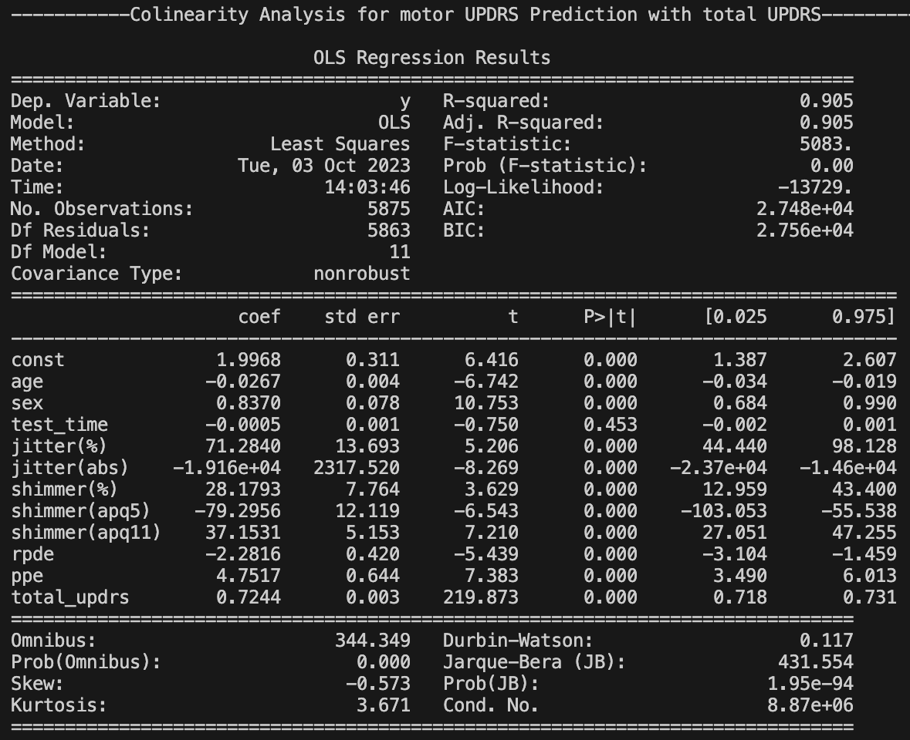

Figure 18

From figure 14 and figure 18 it can be said that after removing collinearity the model remains same as before and after R-squared and Adjusted R-Squared values are same.

**Z-Standardization (Motor UPDRS Prediction)**

To make the model to perform better and standardize all the values of explanatory variables we have conducted Z-standardization and observe the improvement.

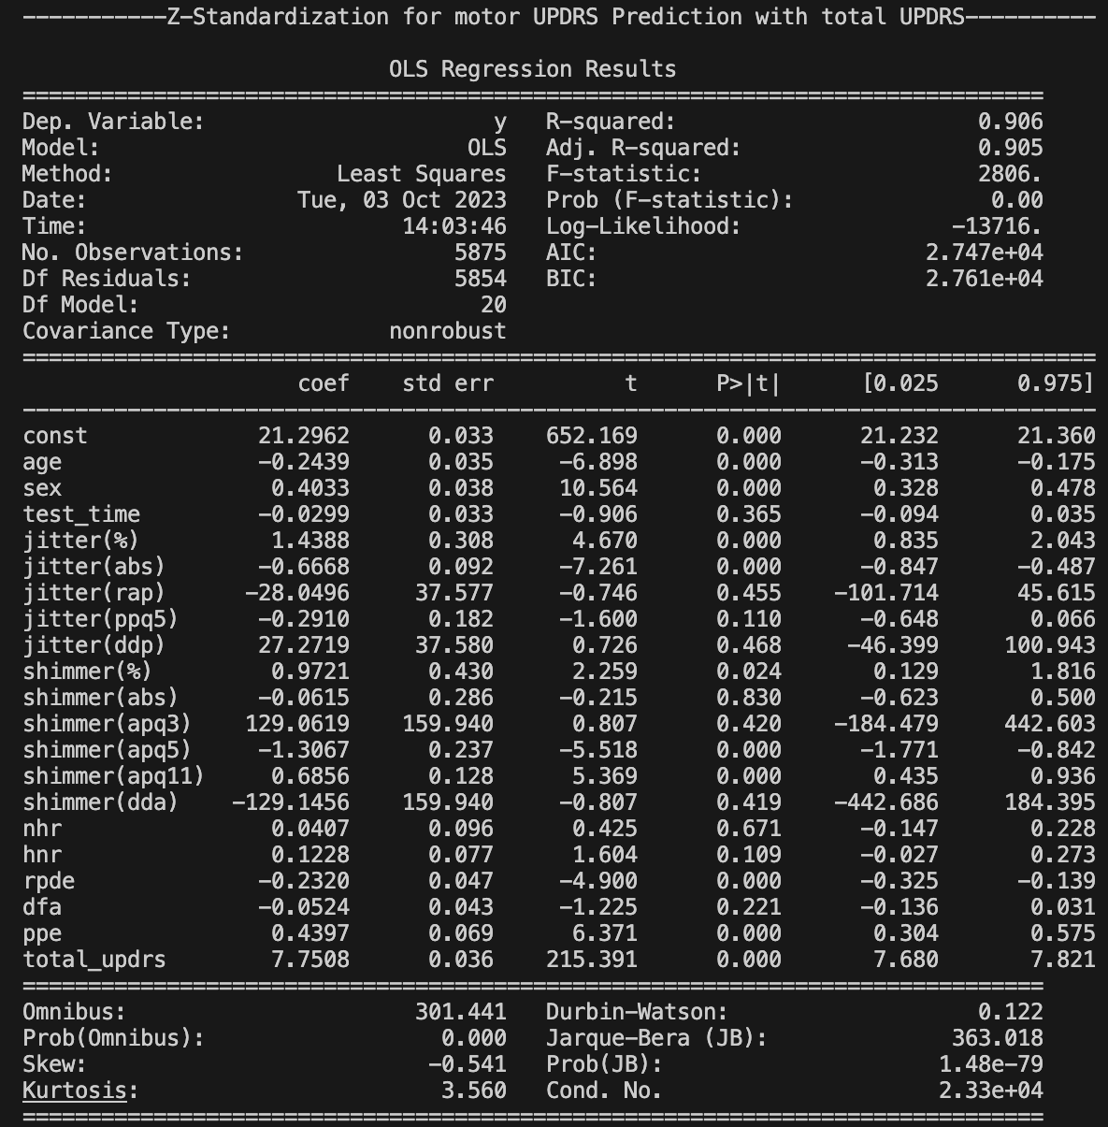

Figure 19

Comparing the R-Squared and Adjusted R-Squared value of the model of figure 19 with the primary model of figure 14, it is clearly observed that there is no improvement after executing this technique.

**Gaussian Transformation** **(Motor UPDRS Prediction)**

To make the explanatory variables normally distributed and improve the model performance Gaussian transformation is applied over the explanatory variables and observed the result.

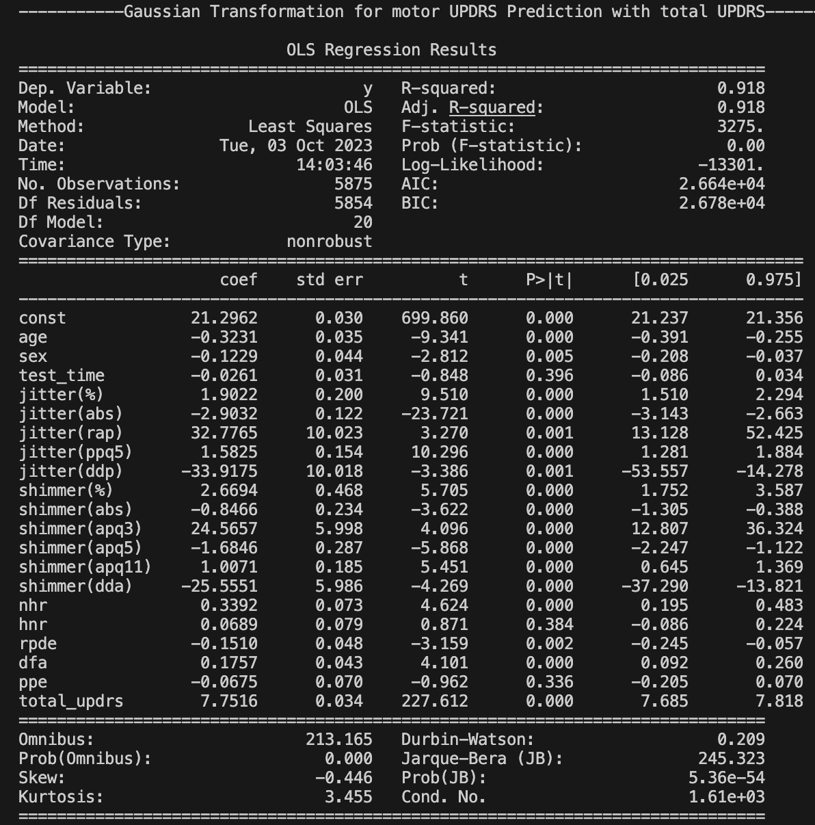

Figure 20

By comparing figure 20 with figure 14 it is clearly visible that model performance is increased as R-Squared value increases from 0.906 to 0.905 and adjusted R-squared value increases from 0.918 to 0.918.

**Primary Model (Total UPDRS Prediction)**

Result for primary MLR model to predict motor UPDRS is given below:

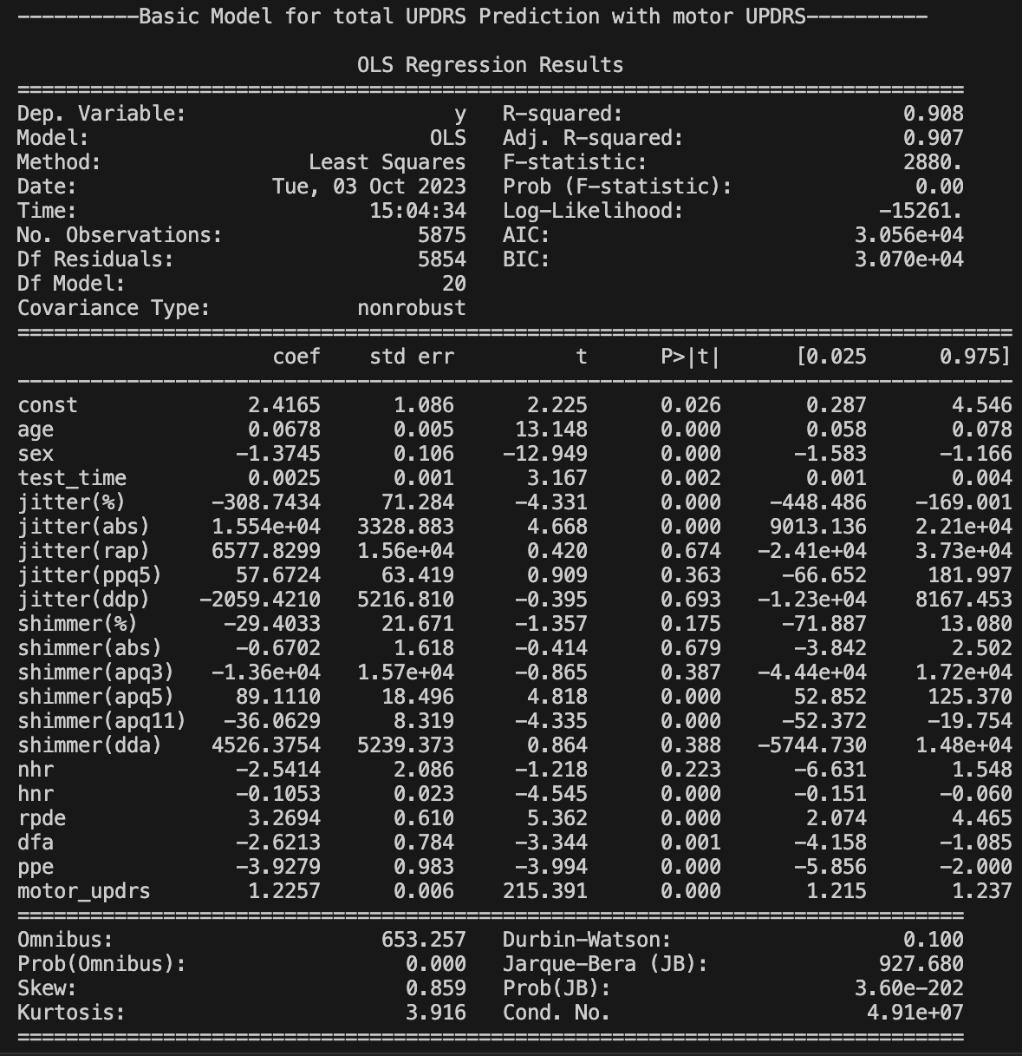

Figure 21

From figure 21 it is visible that R-squared value is 0.908 and Adjusted R-Squared value is 0.907. It seems that model for predicting total UPDRS with **Scenario 2** is good fit, however 4 types of improvement techniques will be applied to improve the model performance.

To visualize and identify the relation of different variables with total UPDRS scatter plots have been generated.

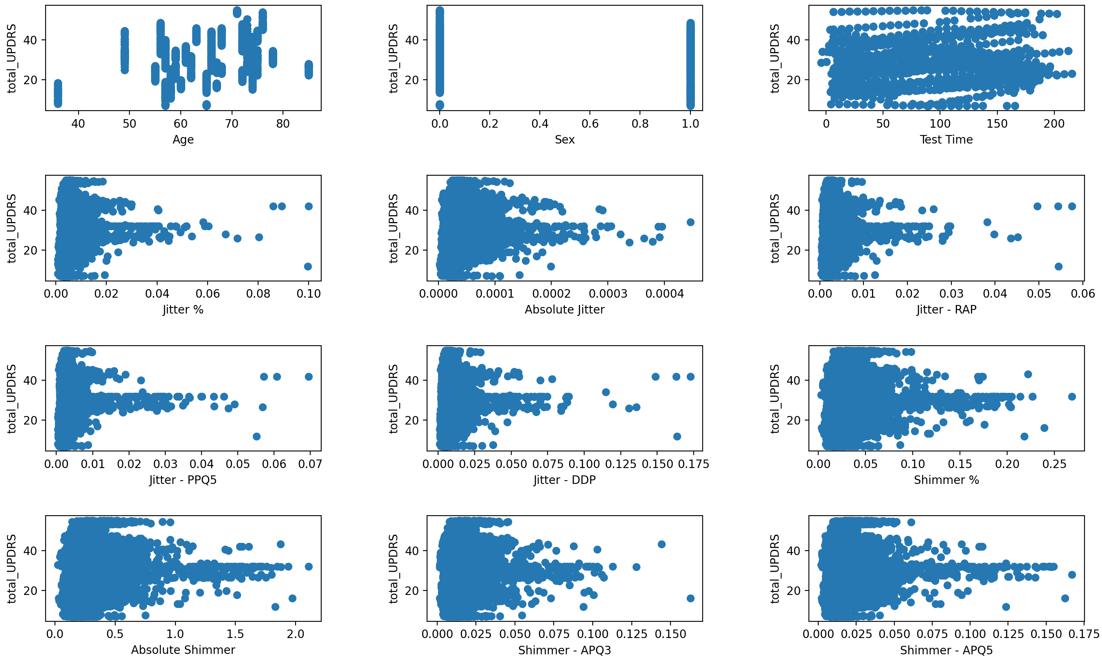

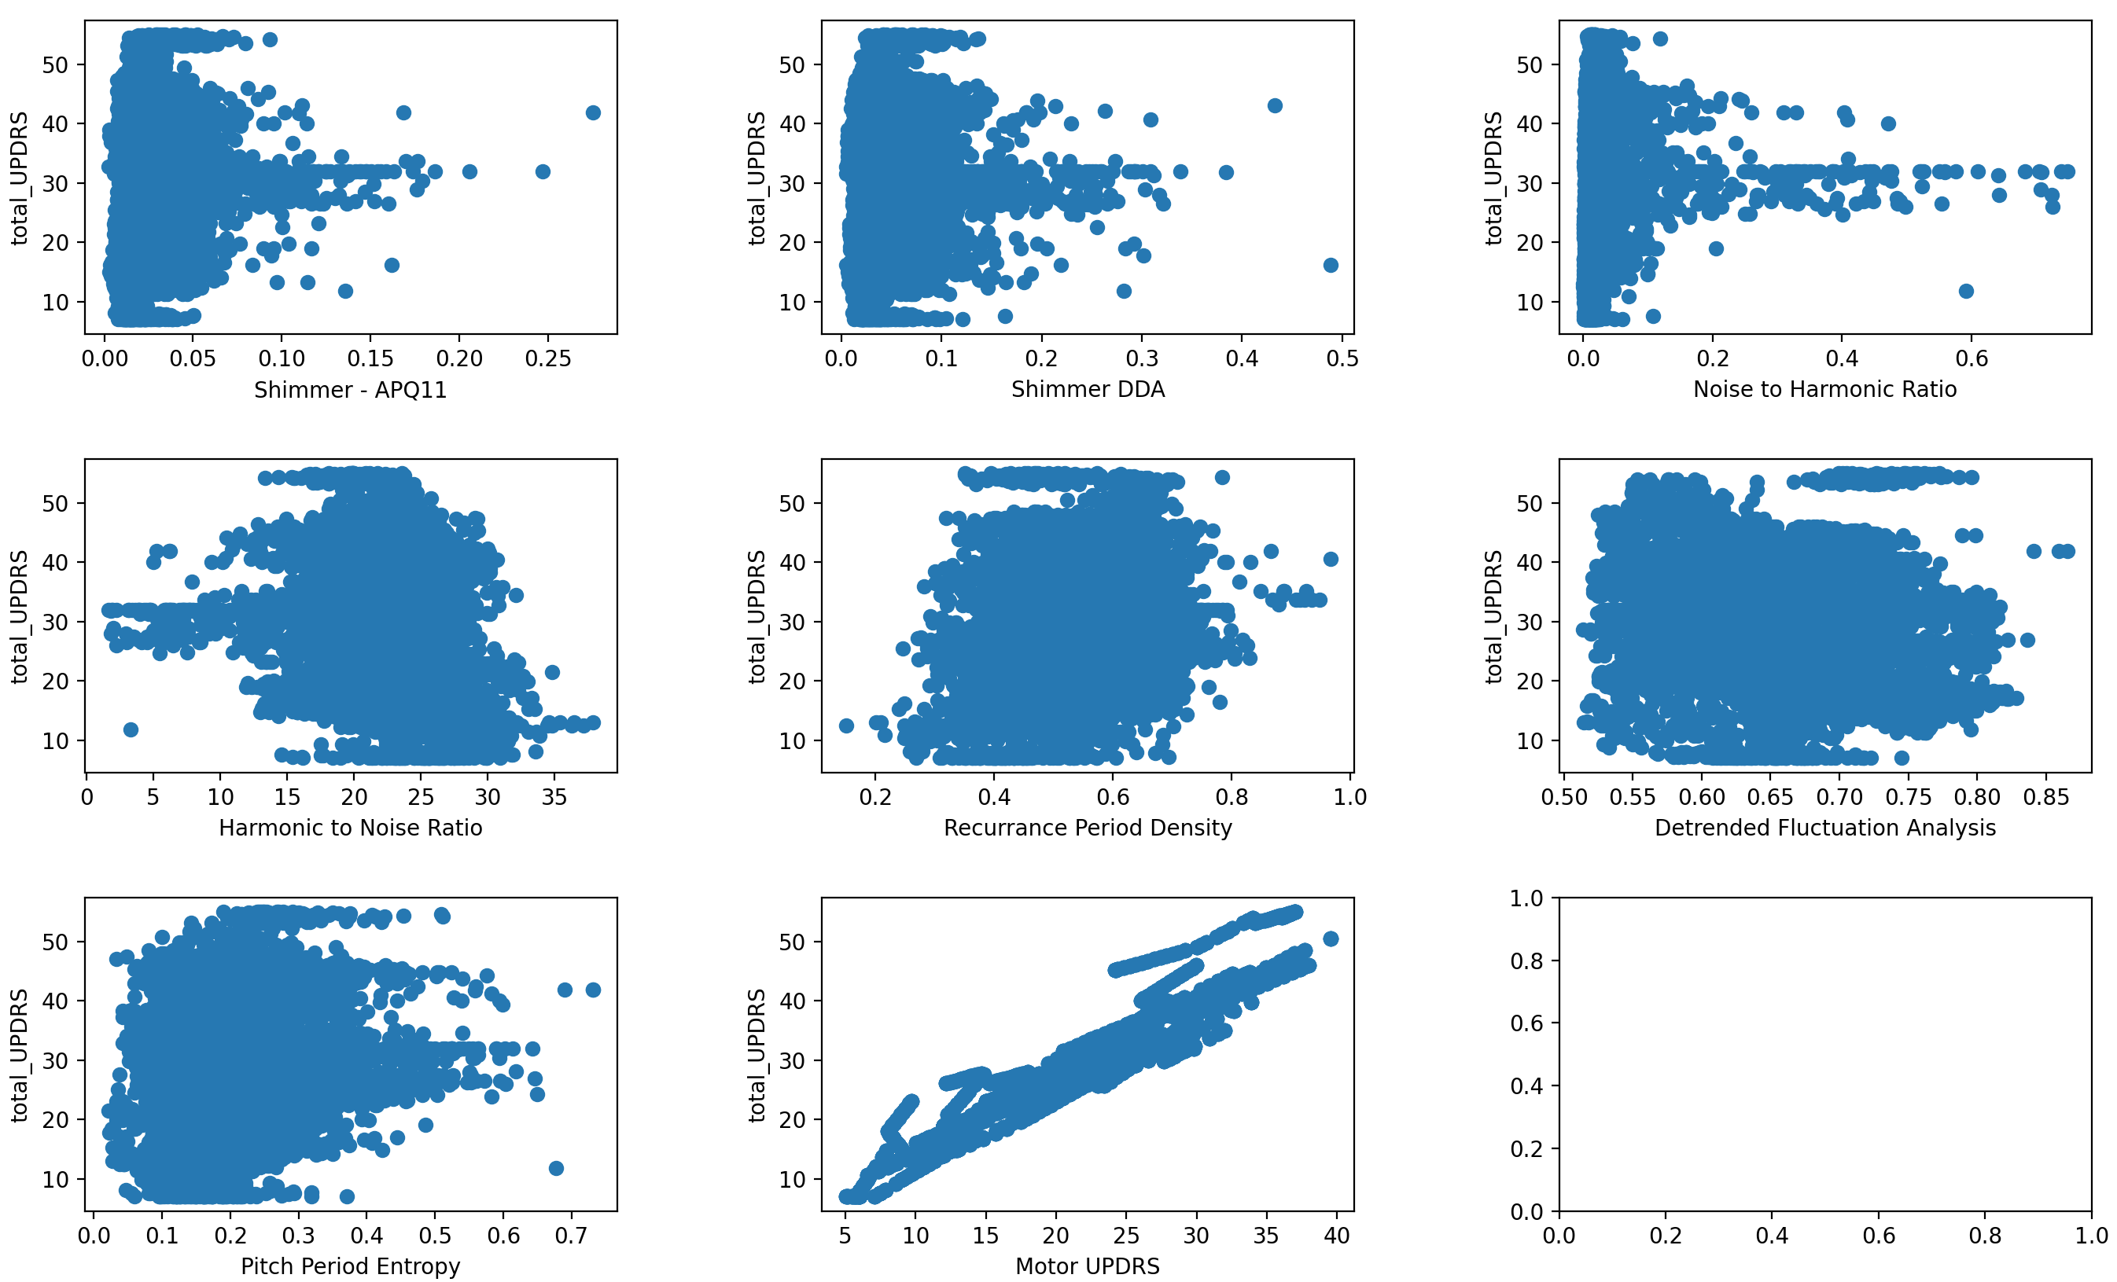

Figure 22

From the figure it can be said that only the motor UPDRS has strong and positive correlation with total UPDRS.

**Linear/Log Transformation (Total UPDRS Prediction)**

Figure 21 shows that sex, test time, recurrence period density, detrended fluctuation analysis and pitch period entropy have somehow linear relation with motor UPDRS. That’s why log transformation is applied except these columns. The result of the MLR model after this transformation is as follow.

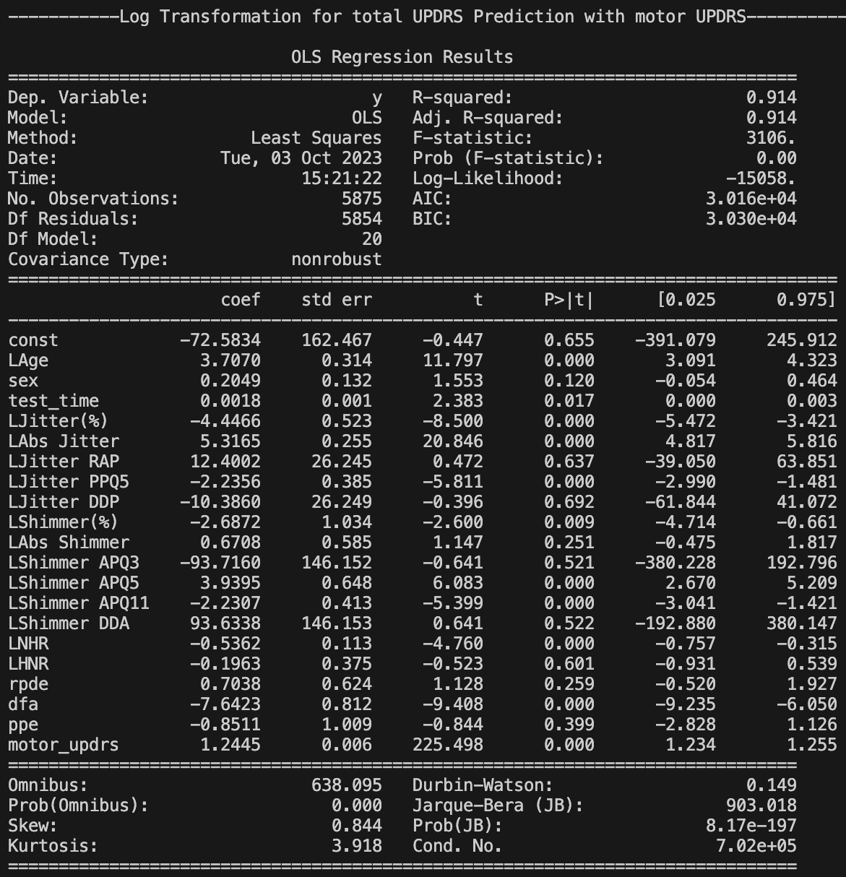

Figure 23

By comparing the R-squared and adjusted R-squared value of figure 23 and figure 21, it is clearly visible that after applying log transformation the model does improve. R-squared value goes up from 0.908 to 0.914 and adjusted R-squared value increases from 0.907 to 0.914.

Figure 21 shows that jitter(rap), jitter(ppq5), jitter(ddp), shimmer (%), shimmer(abs), shimmer(apq3), shimmer(apq5), shimmer(dda), nhr have p-value greater than 0.05 that means these variables have less or no impact in predicting motor UPDRS. Also, these variables have larger correlation with each other, so these variables are dropped to remove the collinearity.

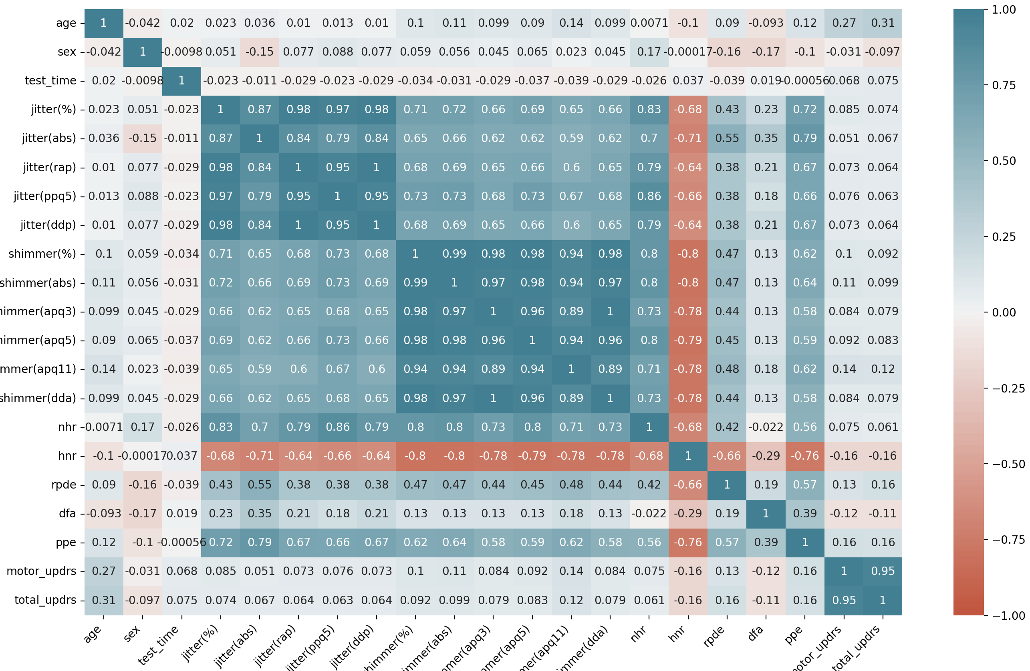

Figure 24

**Removing Collinearity (Total UPDRS Prediction)**

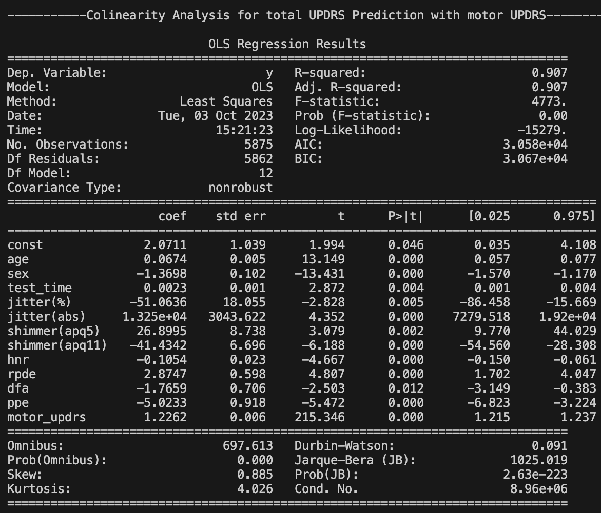

Figure 25

From figure 25 and figure 21 it can be said that after removing collinearity the model remains almost same as before because R-squared and Adjusted R-Squared values are same.

**Z-Standardization (Total UPDRS Prediction)**

To make the model to perform better and standardize all the values of explanatory variables we have conducted Z-standardization and observe the improvement.

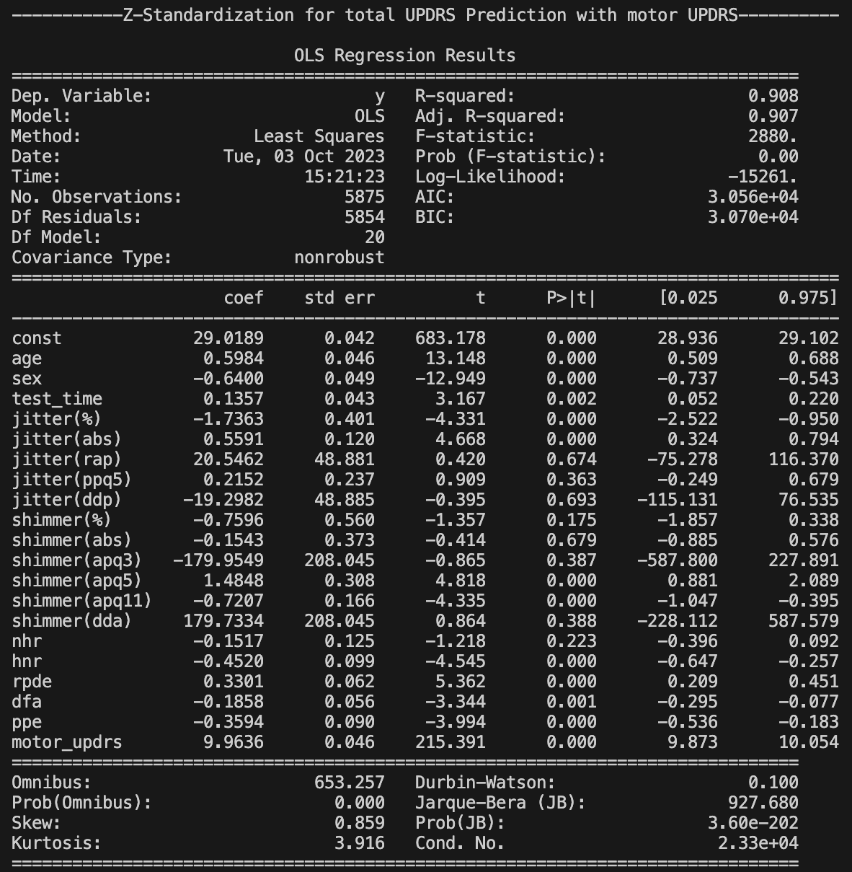

Figure 25

After conducting Z standardization, it is clearly visible from figure 21 and figure 25 that the R-squared value and adjusted R-squared value remain same. So the this is not a fruitful operation for model improvement.

**Gaussian Transformation** **(Total UPDRS Prediction)**

To make the explanatory variables normally distributed and improve the model performance Gaussian transformation is applied over the explanatory variables and observed the result.

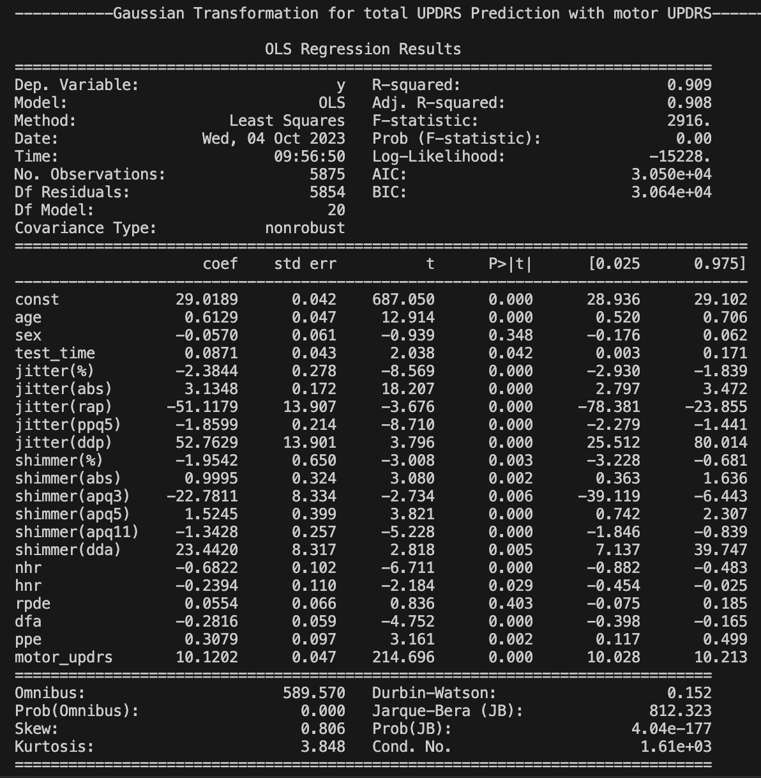

Figure 26

By comparing figure 26 with figure 21 it is clearly visible that model performance is increased slightly as R-Squared value increases from 0.908 to 0.909 and adjusted R-squared value increases from 0.907 to 0.908.

1. **Result and Discussion**

The summary table of analysis is given below:

|  |  |  |  |  |
| --- | --- | --- | --- | --- |
| **Scenario 1** | | | | |
| **Motor UPDRS Prediction** | | | | |
| **Model & Improvement** | **R-Squared** | **Adj. R-Squared** | | **Remark** |
| Primary Model | 0.157 | 0.154 | | Base Model |
| Linear Transformation | 0.163 | 0.160 | | Improve |
| Removing Collinearity | 0.152 | 0.150 | | Not Improve |
| Z-Standardization | 0.157 | 0.154 | | Remain Same |
| Gaussian Transformation | 0.192 | 0.189 | | Improve |
| **Total UPDRS Prediction** | | | | |
| **Model & Improvement** | **R-Squared** | | **Adj. R-Squared** | **Remark** |
| Primary Model | 0.177 | | 0.174 | Base Model |
| Linear Transformation | 0.177 | | 0.175 | Remain Same |
| Removing Collinearity | 0.168 | | 0.167 | Not Improve |
| Z-Standardization | 0.177 | | 0.174 | Remain Same |
| Gaussian Transformation | 0.190 | | 0.188 | Improve |
| **Scenario 2** | | | | |
| **Motor UPDRS Prediction** | | | | |
| **Model & Improvement** | **R-Squared** | | **Adj. R-Squared** | **Remark** |
| Primary Model | 0.906 | | 0.905 | Base Model |
| Linear Transformation | 0.914 | | 0.913 | Improve |
| Removing Collinearity | 0.905 | | 0.905 | Remain Same |
| Z-Standardization | 0.906 | | 0.905 | Remain Same |
| Gaussian Transformation | 0.918 | | 0.918 | Improve |
| **Total UPDRS Prediction** | | | | |
| **Model & Improvement** | **R-Squared** | | **Adj. R-Squared** | **Remark** |
| Primary Model | 0.908 | | 0.907 | Base Model |
| Linear Transformation | 0.914 | | 0.914 | Improve |
| Removing Collinearity | 0.907 | | 0.907 | Remain Same |
| Z-Standardization | 0.908 | | 0.907 | Remain Same |
| Gaussian Transformation | 0.909 | | 0.908 | Improve |

Table 3

Table 3 demonstrates that, at **Scenario 1** while predicting Motor UPDRS model improve after linear transformation and Gaussian transformation but model decline when collinearity removing technique is applied. However, model remain same after Z-standardization. On the other hand, total UPDRS prediction model only improves after gaussian transformation and decline after applying collinearity removal. It remains for the other two improvement techniques.

In the case of **Scenario 2** motor UPDRS and total UPDRS show improvement after applying linear transformation and gaussian transformation, though there is slight improvement in gaussian transformation in total UPDRS prediction. Both the model become same after removing collinearity and Z-standardization.

From that it can be declared that linear transformation and gaussian transformation are the most effective methods for model improvement to predict motor and total UPDRS than the other two methods.

1. **Conclusion**

From the overall observation it is observed that the MLR model to predict the motor UDRS by dropping the total UPDRS column from the data set as well as to predict the total UPDRS by dropping motor UPDRS from the data set give a poor goodness of fit. But if total UPDRS is included in motor prediction and motor UPDRS is included in UPDRS prediction as explanatory variable then the goodness of fit is way higher.

So, motor UDRS and total UPDRS are complementary to each other. So, it is difficult to predict these two variables at a time accurately.

1. **Brief descriptions of individual contributions**

**The total task has been distributed among four team members evenly. Iftekhar Bhuiyan was assigned to do the 1st task which includes building the basic linear regression model to predict motor UPDS and total UPDS based on 60% training and 40% test data. He reported MAE, MSE, NRMSE, R2 and adjusted R2.. Eshayat Hasan took responsibility to solve the second part of the assignment. He analyzed the performance of the linear regression by continuing from previous task. He analysed by splitting 50-50, 60-40,70-30 and 80-20 train and test data respectively. The rest of the part carry forwarded by Reduan Raihan and Aashish. Reduan Raihan did log-transformation and collinearity analysis and reported performance gain. Aashish rebuilt the model by Standardisation and Gaussian transformation and reported the performance gain.**

1. **Reference**
2. https://www.nia.nih.gov/health/parkinsons-disease#:~:text=Parkinson's%20disease%20is%20a%20brain,have%20difficulty%20walking%20and%20talking.
3. https://www.healthdirect.gov.au/parkinsons-disease
4. https://online.stat.psu.edu/stat200/lesson/1/1.1/1.1.2#:~:text=In%20an%20experimental%20study%2C%20the,is%20manipulated%20by%20the%20researcher